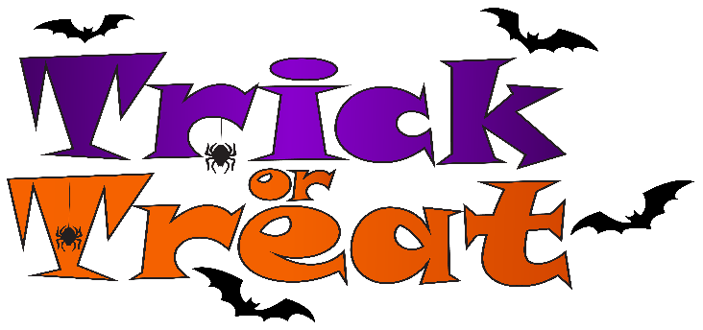

**VILLAGE OF CADOTT**

**2025 HALLOWEEN TRICK OR TREATING**

**HOURS WILL BE**

**5:00 P.M. TO 7:00 P.M.**

**HALLOWEEN DAY – OCTOBER 31ST**

